Class Design - EBR

# Create Initial Design Classes

# Define Relationships Between Classes

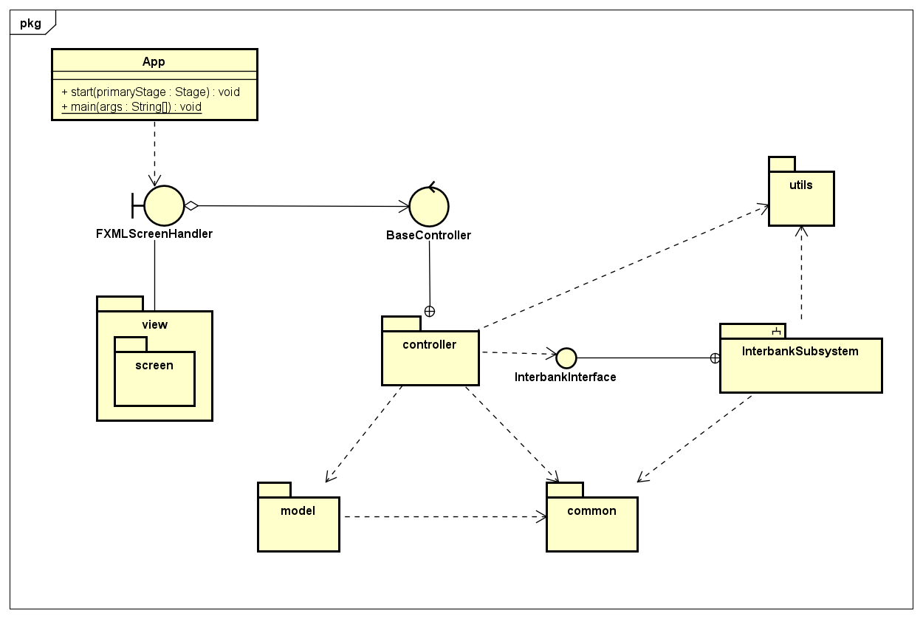

# Class Design

## Class “App”

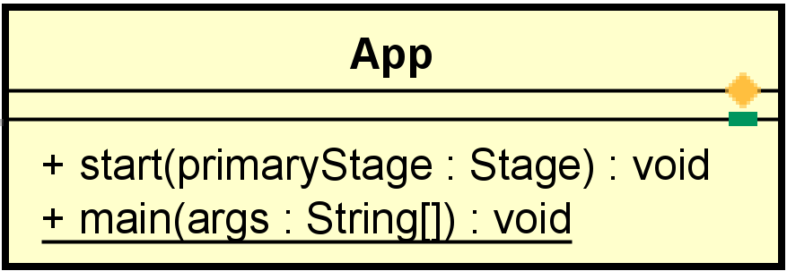

**Attribute**

None

**Operation**

|  |  |  |  |
| --- | --- | --- | --- |
| # | Name | Return type | Description |
| 1 | start | void | javaFx framwork will call this |
| 2 | main | void | execution entry |

**Parameter:**

* start()
  + stage: javaFx main stage

**Exception:**

None

**Method**

None

**State**

None